10.54: a) The moment of inertia is not given, so the angular acceleration must be found from kinematics;

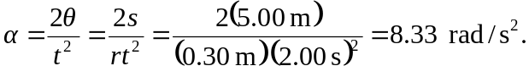
b)
c) The work done by the rope on the flywheel will be the final kinetic energy;

d) 